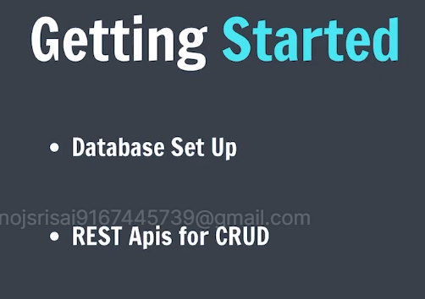

Installing mongoose,ejs,express

Touch app.js

Code in app.js

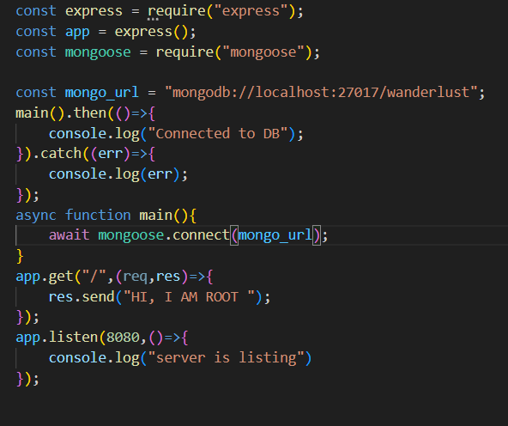

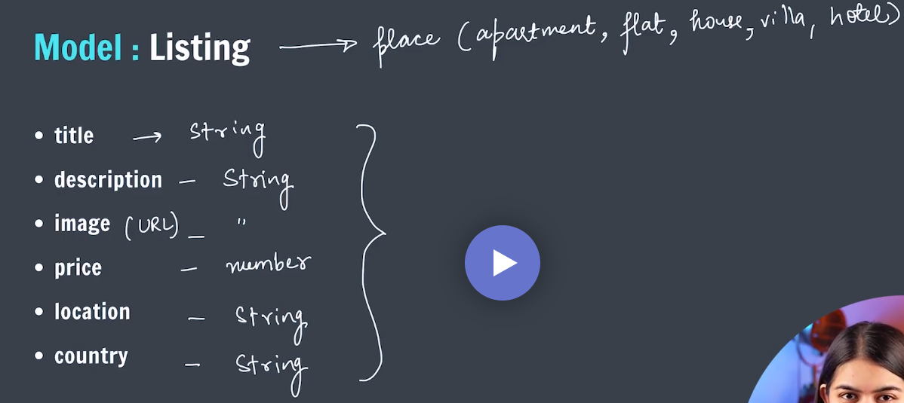

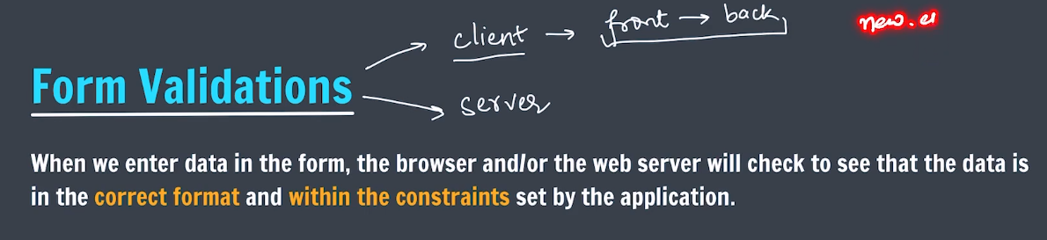

Err.trace

Err.stack

Shows full data of error

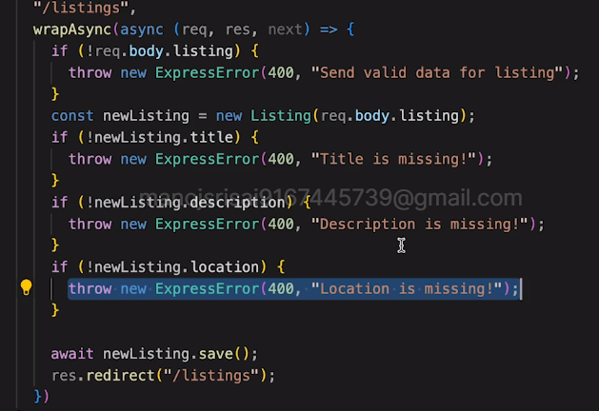

Can validate like this but takes lot of headaches to write for each code for each field

To validate schema individually through fields we use joi a package of npm

Install joi first

And now we define schema

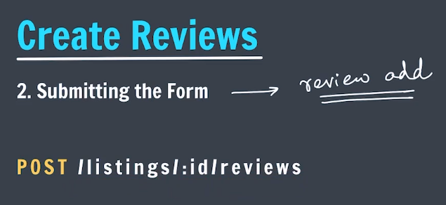

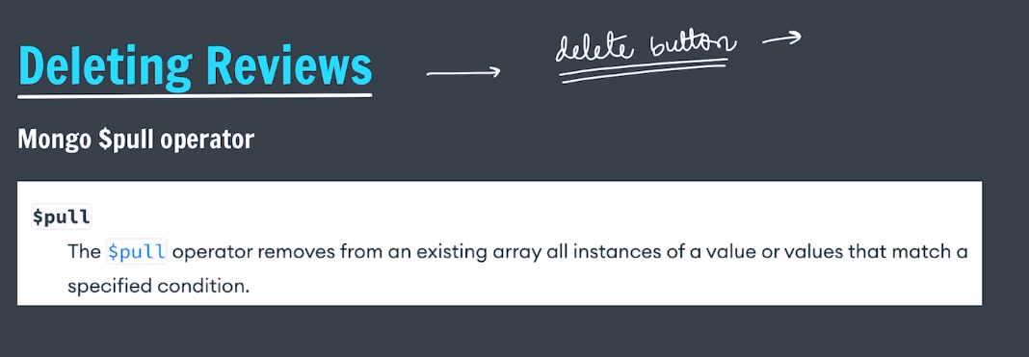



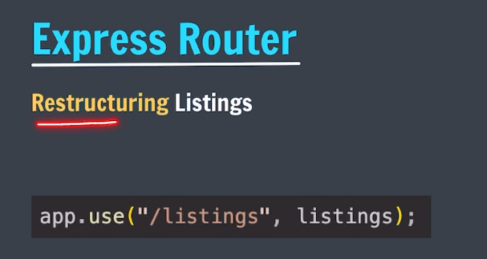

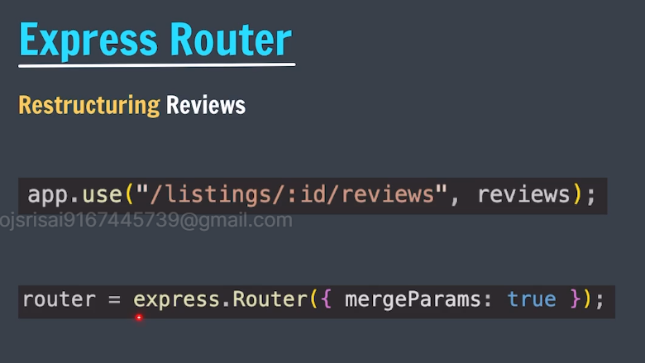

Using mergeparams helps us to get the id value from the parent to the child

Can see express documentation for more details

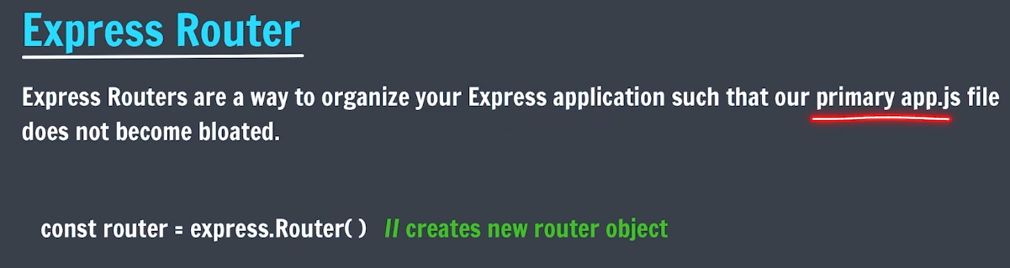

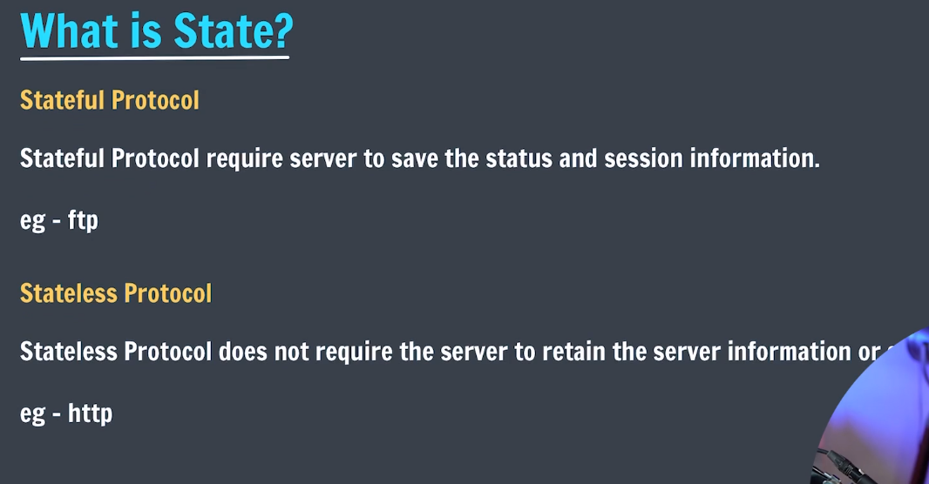

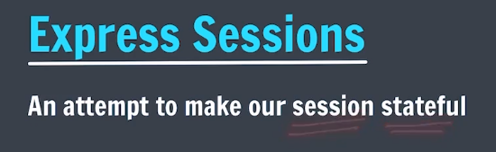

Npm package express-session is used for making sessionid and cookies

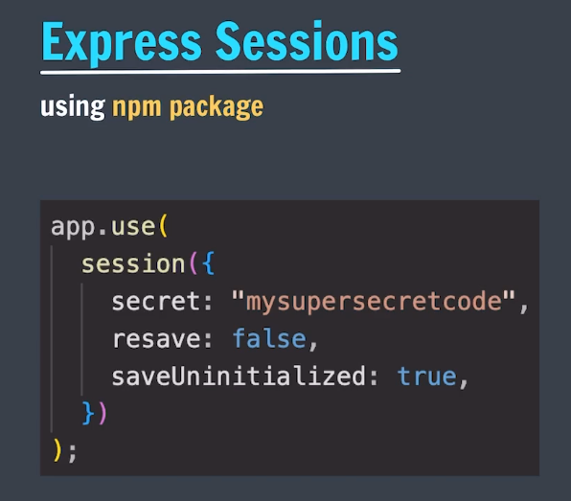

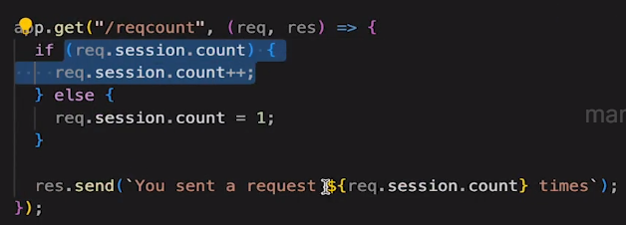



We use connect flash (a middleware to do the above in the website)

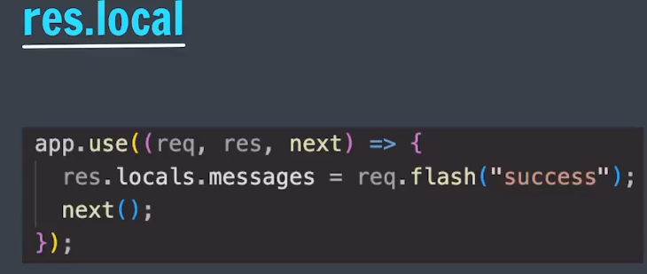



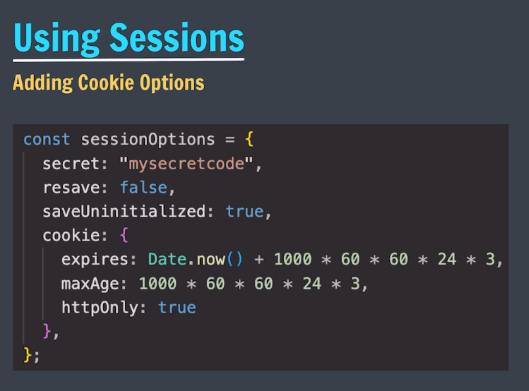

Flash must be used before routes as we use routes to use flash.

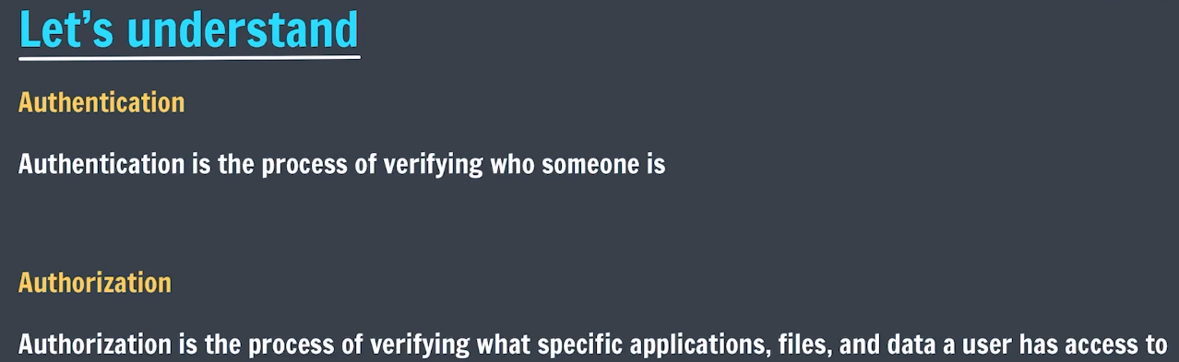

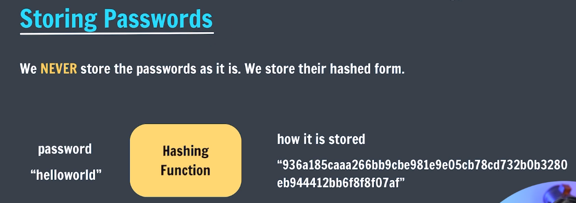

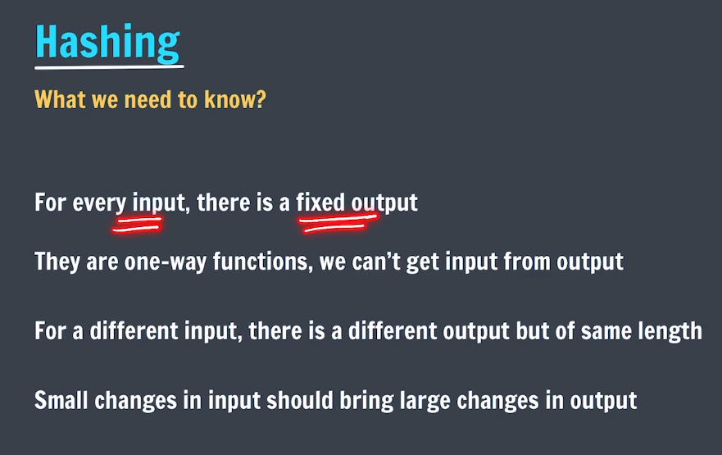

 types of hash functions or algorithms. Hash generator//-

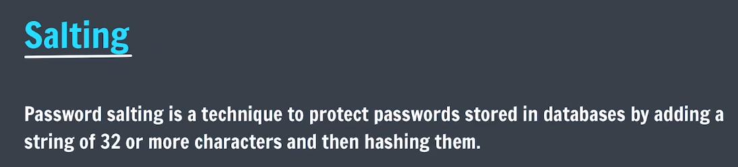

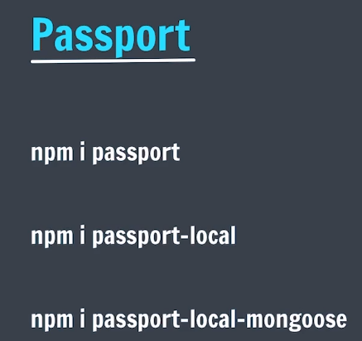

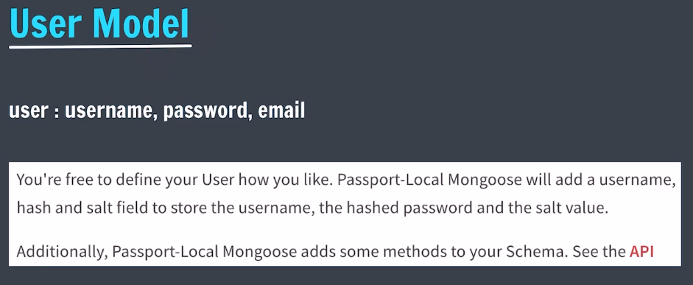

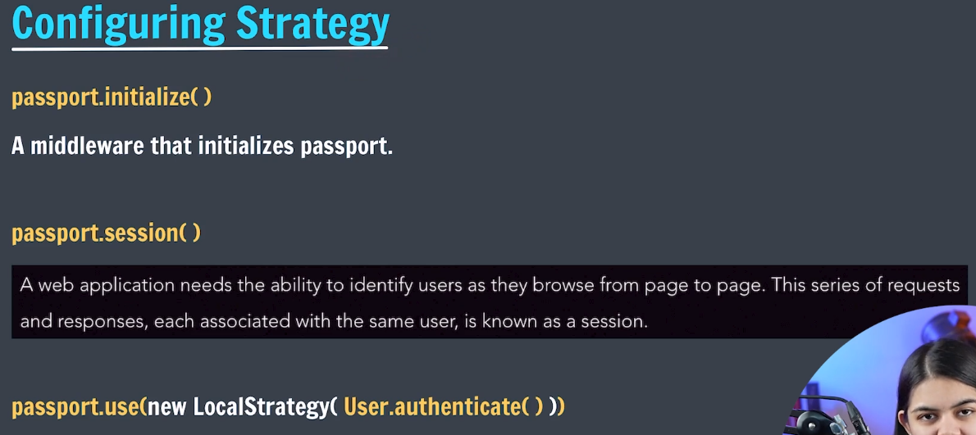

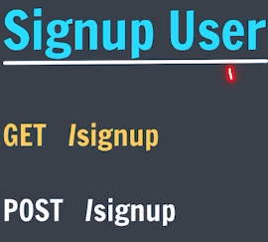

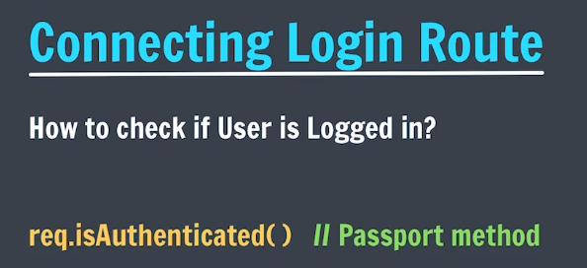

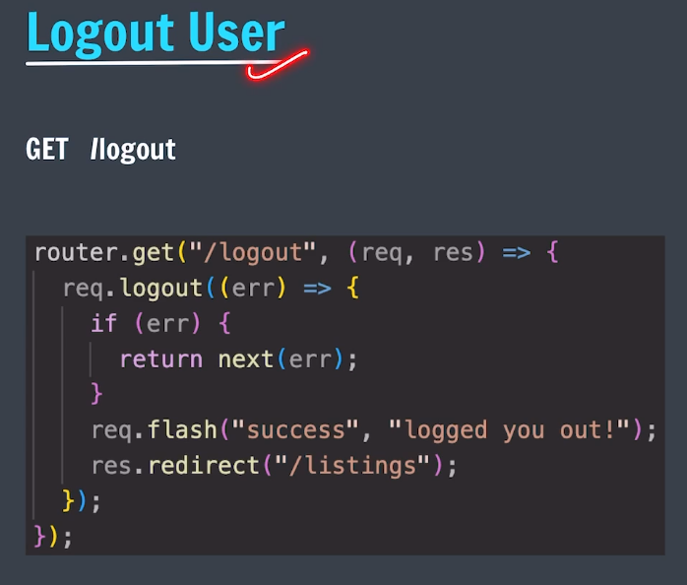

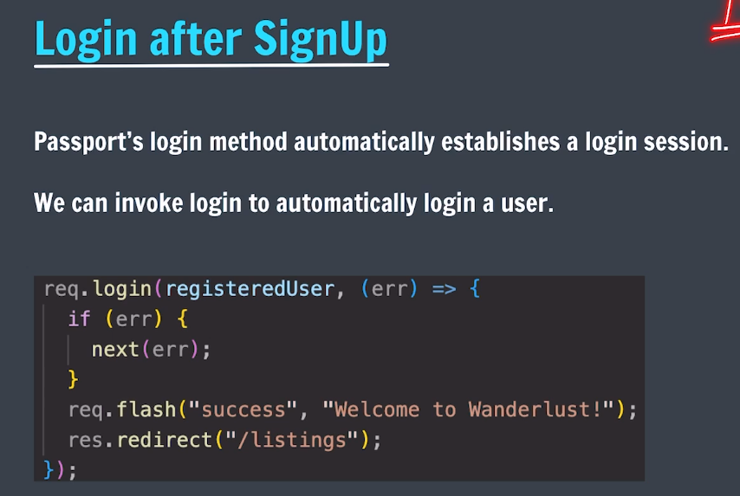

Show.ejs

To display buttons of edit and delete to the user only to who they have asscess.

<% if(currUser && currUser._id.equals(listing.owner._id)) {%>

<% } %>

__________________________________________________________________________________